Meta Data for 2014 North Pole Environmental Observatory CTD-O₂ Profiles collected as part of the aerial hydrographic surveys

Measurements were collected using two Seabird SBE19plus Seacats (serial numbers 5076 and 4000), each outfitted with an SBE43 O₂-sensor (serial numbers 1406 or 0938, see Table 1). The SBE43 sensors were plumbed in-line between the TC cell and Seabird 2.0K pump of each instrument. The CTD-O₂ package was hung below an in-situ ultraviolet spectrophotomer (ISUS) and battery pack, mounted vertically in a stainless steel frame, using 4-inch, locking carabiners. As a consequence of the physical separation between the thermistor and O₂ sensor (as well as the different response times of the two sensors), there is a small lag in time between temperature and O₂ measurements of the same water parcel. As a result, the O₂ data must be “advanced” in time such that the conductivity (salinity), temperature, oxygen, and nitrate data are correctly aligned relative to pressure. The stations occupied during the 2014 field season of the North Pole Environmental Observatory are listed in Table 1. The complete suite of NPEO 2014 CTD data has been archived separately at CADIS. The files described below can be obtained at: http://cdp.ucar.edu/browse/browse.htm?uri=http://dataportal.ucar.edu/metadata/cadis/cadis.thredds.xml. Further details regarding the alignment of the ISUS nitrate profiles are included in a separate README file accompanying those data.
Casts were begun by lowering the instrument package to a depth of ~15 meters to allow the instruments to come to ambient temperature while attempting to prevent any slush ice being pumped into the system. The package was then brought back up to the near surface and six Niskin bottles were attached to the hydrowire at successive intervals in order to sample the seawater at different target depths (20, 50, 75, 100, 150, and 300 m). Once the Niskin bottles were in position, a soak time of 5 minutes was allowed before tripping the bottles via messenger. The bottles were brought back up to the surface and sub-sampled for a variety of chemical variables. This portion of the cast is referred to as the “bottle cast” and is removed from the archived data files. Once the last Niskin bottle was removed from the hydrowire the winch was re-zeroed while the instrument package was near the surface. The package was then lowered through the water column. This portion of the data record is referred to as the “downcast”. Once the package reached 800-900 m, the winch was stopped and the package brought back up to the surface. This portion of the cast is referred to as the “upcast”. The initial parts of the data during which the CTD was lowered, equilibrated, and raised to the surface have been truncated from the final data files. The final data set reported for each station set consists of either downcast or a combination of downcast and upcast data according to the quality of the data collected (see Table 1).

Table 1. Stations occupied during NPEO 2014. The serial numbers of the CTD instrument and SBE43 oxygen sensor deployed at each station is listed. The data reported for each cast was either restricted to the downcast or, in some cases, both downcast and upcast data were used (see text for details).
Cast | Date | Station | CTD | SBE43 | Down or up cast?
1 | 12-Apr-14 | 89N, 13E (Brno 1) | 5076 | 1406 | down
2 | 15-Apr-14 | 87N, 180 | 5076 | 1406 | both
3 | 16-Apr-14 | 87N, 90E | 5076 | 1406 | both
4 | 16-Apr-14 | 89N, 16E (Brno 2) | 5076 | 1406 | both
5 | 17-Apr-14 | 85N, 90E | 5076 | 0938 | both
6 | 17-Apr-14 | 86N, 90E | 5076 | 0938 | both
7 | 18-Apr-14 | 90N | 5076 | 0938 | down
8 | 20-Apr-14 | 88N, 14E (Brno 3) | 4000 | 1406 | down
9 | 21-Apr-14 | 86N, 75W (L6) | 4000 | 1406 | down
10 | 23-Apr-14 | 85N, 68W (L5) | 4000 | 1406 | down
11 | 23-Apr-14 | 84N, 68W (L4) | 4000 | 1406 | down
12 | 23-Apr-14 | 87N, 80W (L7) | 4000 | 1406 | down
13 | 24-Apr-14 | 83N, 65W (L1) | 4000 | 1406 | down
14 | 24-Apr-14 | 84N, 65W (L3-2) | 4000 | 1406 | down

The 4 Hz raw data consisted of scan number, pressure, temperature (ITS-90), conductivity, and SBE43 oxygen sensor voltage. The data were processed using SBEDataProcessor (Version 7.12) according to the following steps:

(1) The raw data was converted using appropriate configuration (CON) file such that the output variables included time, pressure, temperature, conductivity, and SBE43 voltage. Hysteresis and tau corrections were applied to SBE43 voltage data with a 2-sec window.

(2) The temperature and conductivity data were then filtered using a 0.5 second low pass filter whereas the pressure and SBE43 voltage were smoothed using a 1.0 second low pass filter, in accordance with Seabird’s recommendations for SBE19 plus data processing.

(3) The temperature records were advanced 0.55 seconds with respect to pressure, as determined by Roger Andersen (APL-UW) on the basis of salinity spiking minimization (Seabird recommends an advance of 0.5 seconds due to the relatively slow response of the temperature sensor with respect to those of the conductivity and pressure sensors; it is possible the cold Arctic environment resulted in a slightly slower than usual sensor response). The SBE43 voltage was advanced 2.5 seconds relative to pressure to account for the lag time between the flow of the sample from the thermistor to the O₂ sensor.

(4) Cell thermal mass corrections (alpha = 0.025, tau = 9.0) were applied.

(5) Additional variables were derived from the processed data, including depth (salt water, m) computed assuming a constant latitude of 87ºN, potential temperature (ITS-90, deg C), salinity, potential density (sigma-theta, kg m⁻³), and dissolved oxygen concentration (mL L⁻¹). The oxygen concentration was calculated using the Murphy-Larson equation, incorporating a cubic temperature correction and a feature-sharpening term (tau) involving the time derivative of SBE43 voltage.

(6) For stations where the oxygen concentrations recorded during the downcast exhibited a negative bias, upcast data were reported. However, the upcast data were only reported for the specific depth range in which the downcast data were erroneous (i.e., after removing the data with negative bias from the downcast, upcast data were used to fill in the gaps). In other words, data collected during the upcasts were used to “patch” the downcast (see Fig. 1). This step was necessary because the oxygen concentrations recorded during the upcasts also exhibited biases, but these were observed in the shallowest depth range (0-100 m).
An additional advance was necessary to properly align the data acquired during the upcast relative to pressure. Typically, the movement of the instrument package upward through the water column results in the displacement of water parcels immediately surrounding the instrument(s). This is referred to as the wake effect and results in an offset between data acquired during the downcast versus the upcast (relative to pressure). To correct for this wake effect, the dissolved oxygen was advanced by an additional 3.0 seconds relative to pressure. This advance was computed as 2 x 1.5 sec., where the 1.5 sec. advance was determined as the mean advance necessary to superimpose the downcast and upcast temperature records. This advance is necessary because both the downcast and upcast records are shifted during the calculation of the 1.5 sec. advance. Therefore, the advance necessary to overlay the upcast and the initial downcast (prior to any advancement) is 1.5 + 1.5 = 3.0 seconds. In other words, the advanced upcast data should be aligned (relative to pressure) exactly as the downcast data. Oxygen concentrations from this advanced upcast data were used to “patch” portions of the downcast that exhibited significant negative bias in Casts 2-6 (e.g., see Fig. 1). Therefore, both downcast and upcast data were merged together to construct the final data file published for these casts (see Table 1). In operating the SBE-19plus during the NPEO hydro survey, we found that the SBE-43 oxygen readings showed significant deviations particularly when the CTD was stopped to install sample bottles. Finally we realized that this was in fact related to inertial forces acting on the water within the conductivity cell-oxygen sensor and pump plumbing. For shipboard operation Sea-Bird advises that the outlet of the plumbing system be at the same vertical position as the inlet to balance inertial forces within the plumbing; even under rapid deceleration, the pressure differential on the outlet side of the plumbing balances the pressure differential across the inlet side so that deceleration produces no net pressure difference and consequently no change in flow speed through the plumbing. With this in mind we added approximately 20 cm of Tygon tubing to the outlet side of the Sea-Bird pump and terminated this a few cm about the inlet to the conductivity cell. This simple addition eliminated the acceleration-deceleration induced excursions in the oxygen readings.

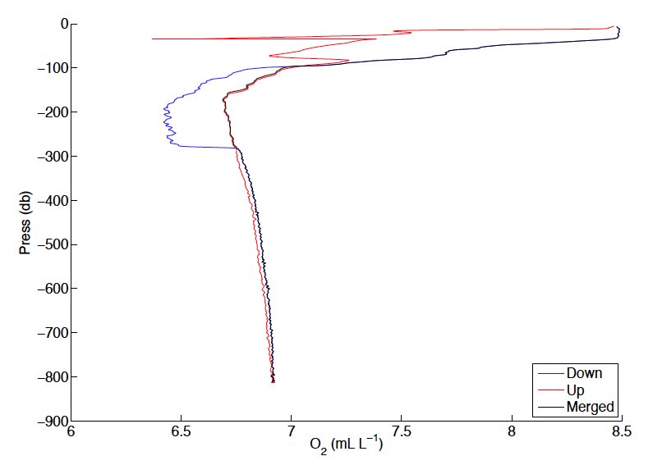
Figure 1. Vertical profiles of dissolved oxygen measured during the down (blue) and up (red) casts at station 86N, 90E during NPEO 2014. The Merged profile substitutes data collected during the upcast for the negatively biased data recorded during the downcast. Merged data are reported for Casts 2-6 (Table 1).

Comparison between CTD and bottle oxygen concentrations
The oxygen concentrations measured by the Seabird SBE43 sensors agreed well with those derived from discrete samples collected using the Niskin bottles and analyzed using the Winkler method (Fig. 2). This good agreement suggests the sensor-based data can be used without adjustment to the factory calibration coefficients. However, the constant offset of 0.12 mL L⁻¹ suggests the sensor data may underestimate the true oxygen concentrations by this amount. However, according to specifications published by the manufacturer, oxygen concentrations measured by the sensor should be accurate to within ± 0.1 mL L⁻¹, quite close to the estimated offset. In addition, a comparison of three separate profiles collected at station Barneo (Casts 1, 4, and 8; see Table 1) indicated that the oxygen concentrations agreed to within ± 0.15 mL L⁻¹ in the mixed layer and within features (minimum or maximum oxygen layers) common among the profiles (data not shown). We have therefore applied no correction to the oxygen concentrations derived from the oxygen sensor and leave the decision to the user whether or not to correct for this apparent offset.
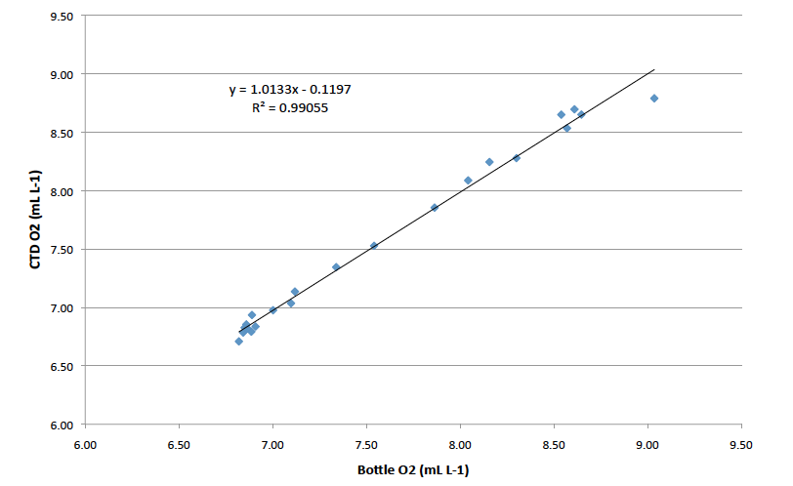
Figure 2. Linear regression of oxygen concentrations derived from discrete samples collected from Niskin bottles and analyzed using the Winkler method (x-axis) against concentrations measured by Seabird SBE43 sensors (y-axis).

The final data files each consist of 12 columns of data:

(1) = Scan
(2) = Pressure, Strain Gauge [db]
(3) = Temperature [ITS-90, deg C]
(4) = Depth [salt water, m], lat = 87
(5) = Potential Temperature [ITS-90, deg C]
(6) = Salinity [PSU]
(7) = Potential Density [sigma-theta, kg m⁻³]
(8) = Oxygen [mL L⁻¹]
(9) = Oxygen [mmol m⁻³]
(10) = Oxygen [μmol kg⁻¹]
(11) = oxsat [mL L⁻¹], calculation method: garcia-gordon

This data was collected under the support of NSF grant OPP-0634122 to K. Falkner and OPP-9910305 to J. Morison. Any opinions, findings, and conclusions or recommendations expressed in this material are those of the author(s) and do not necessarily reflect the views of the National Science Foundation.

For further information, please contact:

Dr. Matthew Alkire
malkire@apl.washington.edu
(206) 896-1623
Applied Physics Laboratory
University of Washington
1013 NE 40th Street
Seattle, WA 98105

