Meta Data for North Pole Environmental Observatory 2014 ISUS Nitrate Survey

Measurements were collected using two Seabird SBE19plus Seacats (serial numbers 5076 and 4000), each outfitted with an SBE43 O₂-sensor (serial numbers 1406 or 0938). The SBE43 sensors were plumbed in-line between the TC cell and Seabird 2.0K pump of each instrument. The CTD-O₂ package was hung below an in-situ ultraviolet spectrophotomer (ISUS V3, serial #128) and battery pack, mounted vertically in a stainless steel frame, using 4-inch, locking carabiners. The stations occupied during the 2014 field season of the North Pole Environmental Observatory at which the ISUS was deployed of are listed in Table 1. The complete suite of NPEO 2014 Nitrate data has been archived separately at CADIS. The files described below can be obtained at:

http://cdp.ucar.edu/browse/browse.htm?uri=http://dataportal.ucar.edu/metadata/cadis/cadis.thredds.xml.

The CTD-O₂ data processing steps are described separately in the README file accompanying those data and will not be repeated here. These data can also be accessed at CADIS.

Table 1. Stations occupied during NPEO 2014. The serial numbers of the CTD instruments and SBE43 oxygen sensors deployed at each station are also listed. The acronym “Brno” refers to multiple casts completed from the Barneo Ice Camp base of operations.
Cast | Date | Station | N Latitude  (dec. deg.) | E Longitude  (dec. deg.) | CTD | SBE43
1 | 12-Apr-14 | 89N, 13E (Brno 1) | 88.981 | 13.665 | 5076 | 1406
2 | 15-Apr-14 | 87N, 180 | 86.998 | 179.646 | 5076 | 1406
3 | 16-Apr-14 | 87N, 90E | 87.017 | 90.583 | 5076 | 1406
4 | 16-Apr-14 | 89N, 16E (Brno 2) | 88.621 | 16.177 | 5076 | 1406
5 | 17-Apr-14 | 85N, 90E | 85.005 | 90.189 | 5076 | 0938
6 | 17-Apr-14 | 86N, 90E | 85.943 | 89.898 | 5076 | 0938
7 | 18-Apr-14 | 90N | 89.985 | -1.483 | 5076 | 0938

Casts were begun by lowering the instrument package to a depth of ~15 meters to allow the instruments to come to ambient temperature while attempting to prevent any slush ice being pumped into the system. The package was then brought back up to the near surface and six Niskin bottles were attached to the hydrowire at successive intervals in order to sample the seawater at different target depths (20, 50, 75, 100, 150, and 300 m). Once the Niskin bottles were in position, a soak time of 5 minutes was allowed before tripping the bottles via messenger. The bottles were brought back up to the surface and sub-sampled for a variety of chemical variables. This portion of the cast is referred to as the “bottle cast”. Once the last Niskin bottle was removed from the hydrowire the winch was re-zeroed while the instrument package was near the surface. The package was then lowered through the water column. This portion of the data record is referred to as the “downcast”. Once the package reached 800-900 m, the winch was stopped and the package brought back up to the surface. This portion of the cast is referred to as the “upcast”. This order of operations was found to be optimal for ISUS measurement as it allowed sufficient time for the instrument to warm up and equilibrate with its environment.

The bottle cast, upcast, and initial measurements corresponding to the period during which the CTD was lowered, equilibrated, and raised to the surface have been truncated from the final data files. The final data set reported for each station therefore consists of measurements collected during the downcasts only. However, oxygen concentrations included in the data files for Casts 2-6 also include measurements collected during the upcast due to issues with the O₂ sensor equilibration (further details are provided in the README file accompanying the CTD-O₂ data).

Details regarding ISUS data processing have been previously reported in Alkire et al. [2010]. Here the data processing steps are briefly described. Since the ISUS does not record pressure or external temperature, the separate ISUS and CTD casts were merged after collection using the respective internal timestamps of their first data record. Following synchronization, the resulting data files were then processed using a program (ISUSDataProcessor) developed by Ken Johnson (MBARI), which incorporates salinity and temperature data from the CTD and applies algorithms that correct the spectral data collected by the ISUS for temperature effects on the bromide absorption [Sakamoto et al., 2009]. Each nitrate concentration calculated has an associated fit-error (RMS deviation of observed nitrate absorbance from modeled values). Any concentrations with fit-errors exceeding 0.003 were omitted from the final data files to accommodate known instrumental noise (Ken Johnson, personal communication). The value of 0.003 used as the criterion for determining the quality of the fit was somewhat higher than that used (0.002) in previous years. Fit errors of 0.002-0.003 were most frequently associated with nitrate concentrations measured within the top 50-100 m of the water column and omission of all data associated with fit errors > 0.002 resulted in truncated profiles with the top 0-100 m missing. We have therefore chosen to accept a lower quality of fit to extend the nitrate profiles over the full depth of the water column rather than omit the top ~100 m. We have no sure explanation for the higher fit errors encountered during the 2014 deployment but speculate that the use of a borrowed instrument (V3, serial #128) rather than the V2 ISUS (serial #127) we have deployed in previous years (not used in 2014 due to malfunctions) was likely the root cause. Differences in the quality of the instrument and/or cleanliness of the optics may have resulted in an error in the calibration of the sensor response, resulting in slightly worse fits than previously encountered with our V2 ISUS.

Finally, ISUS-derived NO3 concentrations were compared to those measured from seawater samples collected at various depths during each station occupation using simple linear regression (Fig. 1). The coefficients yielded from the regression were used to correct the full downcast profiles of the associated ISUS data via the equation:

ISUS_{correct} = (ISUS – b₀) / b₁

where b₀ = 8.0922 (intercept) and b₁ = 0.7344 (slope)

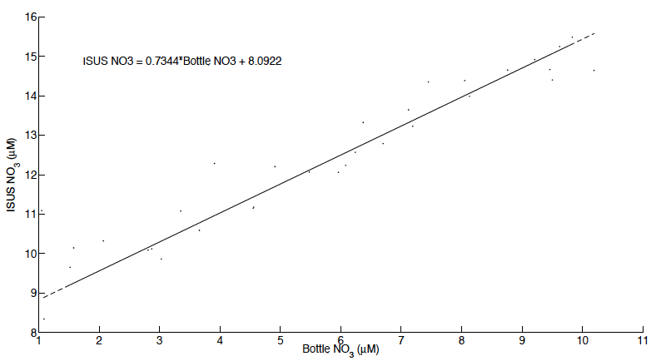
Fig. 1. Scatterplot of nitrate (NO3) concentrations measured from discrete water samples (Bottle NO3) and those using ISUS. The line and equation of the simple linear regression is shown in the figure.

After correction, the bottle- and ISUS-derived nitrate concentrations generally agreed to within ± 0.6 μM with occasionally larger discrepancies of 1-3 μM in regions of rapid change with depth (e.g, nitricline) or features (minima and/or maxima) that can be difficult to capture with discrete samples.

The final data files are tab-delimited ASCII text files, each consisting of 12 columns of data:

(1) = Pressue [db]
(2) = Depth [salt water, m]
(3) = Temperature [ITS-90, deg C]
(4) = Potential Temperature [ITS-90, deg C]
(5) = Salinity [PSU]
(6) = Potential Density [sigma, kg m-³]
(7) = Dissolved Oxygen [mL L⁻¹]
(8) = Dissolved Oxygen [mmol m⁻³]
(9) = Dissolved Oxygen [μmol kg⁻¹]
(10) = Oxygen Percent Saturation [%]
(11) = Nitrate, corrected [μM]

This data was collected under the support of NSF grant OPP-0634122 to K. Falkner and OPP-9910305 to J. Morison. Any opinions, findings, and conclusions or recommendations expressed in this material are those of the author(s) and do not necessarily reflect the views of the National Science Foundation.

For further information, please contact:

Dr. Matthew Alkire malkire@apl.washington.edu (206) 896-1623
Applied Physics Laboratory
University of Washington
1013 NE 40th Street
Seattle, WA 98105

References

Alkire, M.B., K.K. Falkner, J. Morison, R.W. Collier, C.K.Guay, R.A. Desiderio, I.G. Rigor, M. McPhee (2010). Sensor-based profiles of the NO parameter in the central Arctic and southern Canada Basin: new insights regarding the cold halocline, Deep-Sea Research I 57: 1432-1443.

Sakamoto, C.M., K.S Johnson, L.J. Coletti (2009). Improved algorithm for the
computation of nitrate concentrations in seawater using an in situ ultraviolet spectrophotometer, Limnology & Oceanography: Methods 7, 132-143.

